Appetizers  Dog Fries or Dirty Dog Fries / $6-5  House cut fries topped with Carne Asada, avocado dressing, lime sour cream, queso fresco, cheese sauce, and salsa verde or Fries tossed with parmesan cheese, roasted red peppers, garlic, and fried sage/rosemary.  Hummus / $7  Made fresh roasted garlic and roasted red pepper. Served with pita, carrots, and celery sticks.  Hilltop Pretzel / $6  Big soft pretzel with beer cheese and Arkansas Red spicy mustard.  Wings / $9  braised in our Imperial Pilsner giving our wings a very distinct flavor and soft tender texture, fried to a golden crisp and tossed with a hint of salt, pepper, garlic and cayenne.  Vegan  Vegan Tacos / $7  Marinated tofu fried to a golden brown, served in a butter lettuce cup with fried mushrooms, shaved carrots, shaved cabbage, and a light drizzle of go-chu-jang  Power salad /$9  A quinoa salad with roasted kale, walnuts, black berries, strawberries, with a strawberry vinaigrette. |  |  |  | 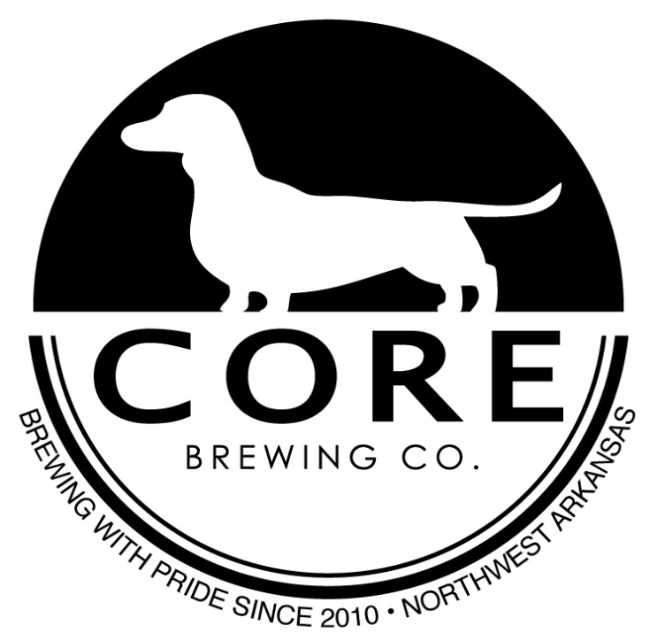  Dessert  Beignets / $5  tossed in powdered sugar and served with a chocolate ganache.  Brew-amisu / $5  Our take on an old classic made in house with our beer.
Sandwiches  All sandwiches served with your choice of fries, chips or upgrade to dog fries-$3  Street Tacos / $2.75 each  Corn tortilla with Carne Asada, topped with avocado dressing, lime sour cream, queso fresco, sliced onion and a pinch of cilantro.  50/50 Burger / $11  Like none before it, Patty made up of 50% beef and 50% black pepper bacon. Served with chipotle aioli, lettuce, and tomato.  Core Burger / $9  Classic as classic can be. Beef patty with bacon, lettuce, tomato, onion and house pickles  Pastrami Burger / $11  Beef patty served with slice of pastrami, arugula, chipotle aioli with a fried egg to top it all off.  Cubano Sandwich / $9  Pork slow cooked in house mojo sauce, ham and swiss cheese, served on grilled sourdough with house made pickles and a ground mustard spread.  Southern Fried Chicken Sammie/ $11  whole double breaded chicken thigh, tossed with house spices and deep fired. Severed with chipotle aioli, lettuce and house made hot pickle.  Fish and Chips / $11  Beer battered cod over a bed of our house fires.  German Mac and Cheese / $8  Adult mac and cheese of your dreams! Stone ground mustard cheese sauce over a bed of pasta, topped with caramelized onions, sliced beer brat, and another layer of gruyere cheese |  |  |  | 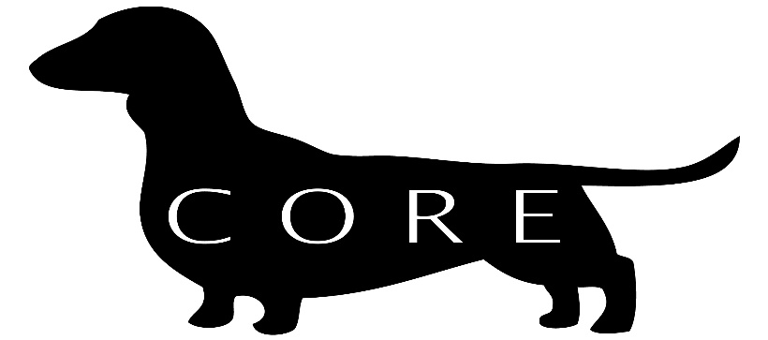  Open Daily  3PM – 9 pm Monday thru Wednesday  3PM – 11PM Thursday & Friday  12PM – 11PM Saturday  12PM – 9PM Sunday  Happy Hour  3PM- 7PM Monday thru Thursday

